WT

ASSIGNMENT

-Riva Kainth

24/SCA/BCA/01

1 .Create a simple HTML page using basic tags.

<!DOCTYPE html>

<html>

<head>

<title>Simple HTML Page</title>

</head>

<body>

<h1>Hello World </h1>

<p>This is a simple HTML page.</p>

</body> </html>

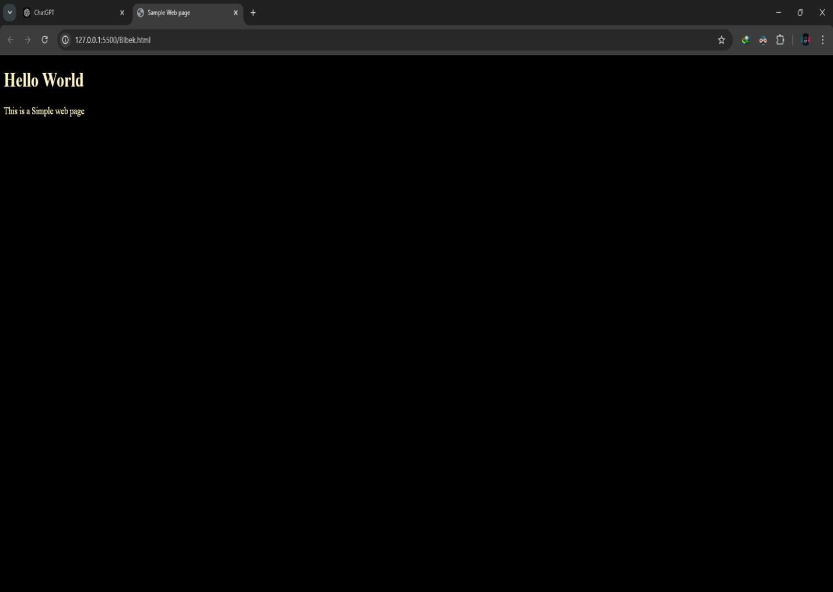

2.Create a web page that displays your name to the screen.

<!DOCTYPE html>

<html >

<head>

<title>Name</title>

</head>

<body>

<h1>Riva</h1>

</body>

</html>

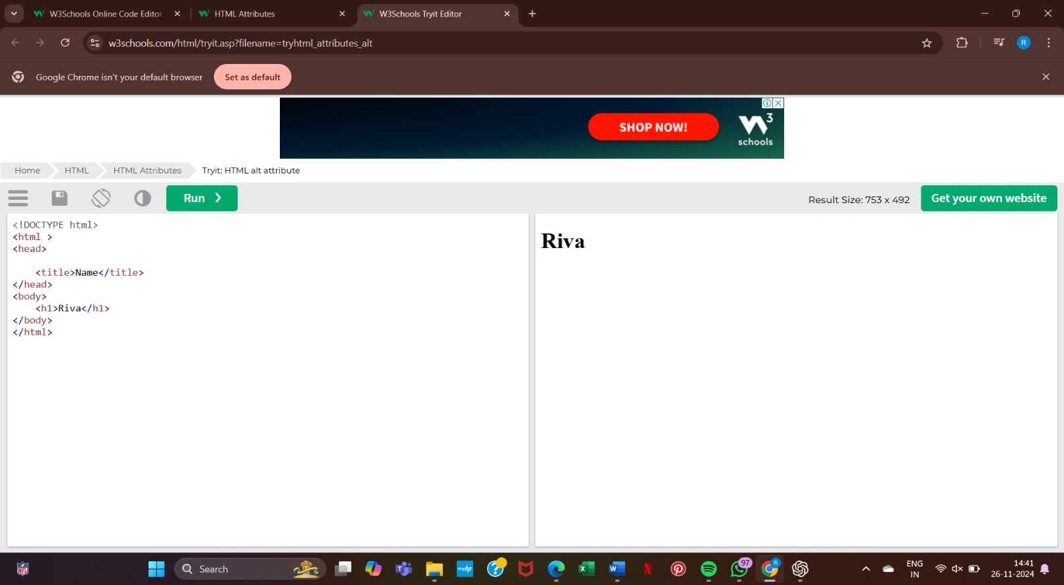

3.Create a Web page and show the output from 1 to 10 in separate lines.

<!DOCTYPE html>

<html>

<head>

<title>Numbers from 1 to 10</title>

</head>

<body>

<h1>Numbers from 1 to 10</h1>

<p>1</p>

<p>2</p>

<p>3</p>

<p>4</p>

<p>5</p>

<p>6</p>

<p>7</p>

<p>8</p>

<p>9</p>

<p>10</p>

</body>

</html>

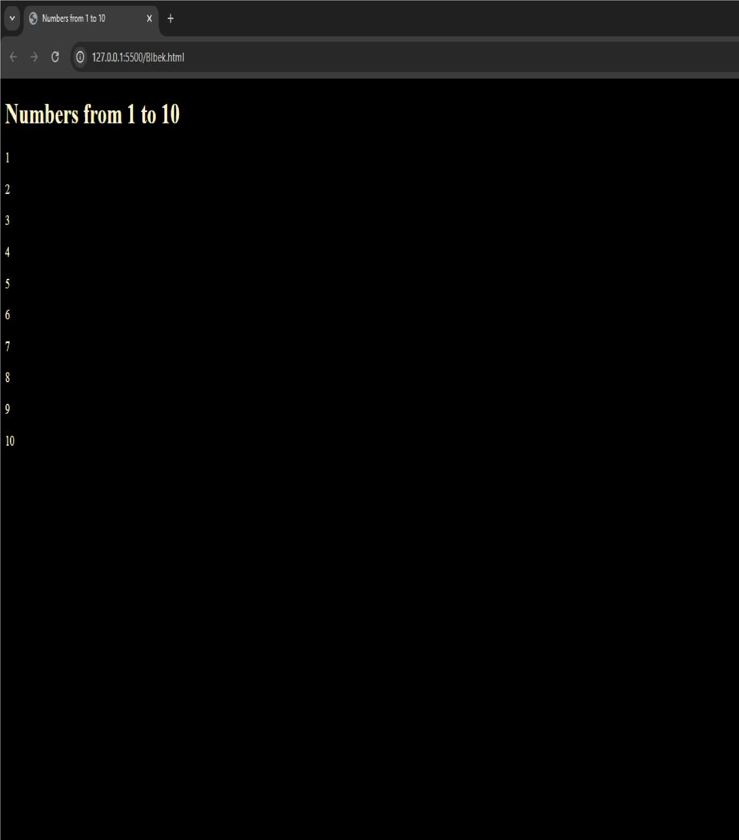

4. Create a web page and show the output from 1 to 10 in separate lines, each number being in different color.

<!DOCTYPE html>

<html >

<head>

<title>Colored Numbers 1 to 10</title>

</head>

<body>

<h1> Number 1 to 10 with different colors</h1>

<p style="color: red;">1</p>

<p style="color: orange;">2</p>

<p style="color: yellow;">3</p>

<p style="color: green;">4</p>

<p style="color: blue;">5</p>

<p style="color: indigo;">6</p>

<p style="color: violet;">7</p>

<p style="color: pink;">8</p>

<p style="color: brown;">9</p>

<p style="color: black;">10</p>

</body>

</html>

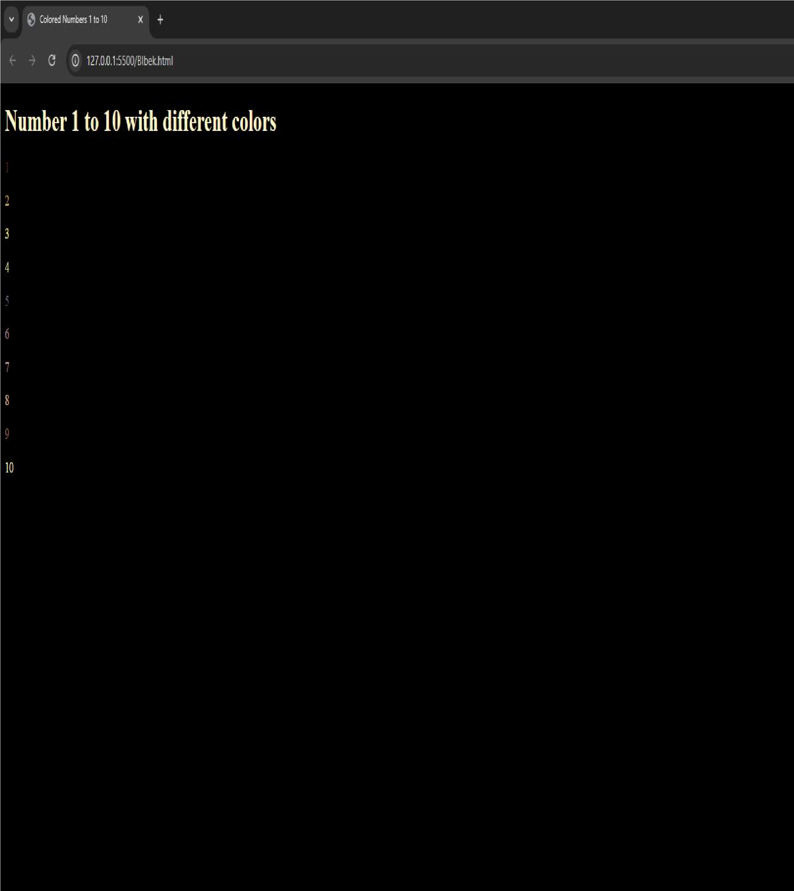

5. How do I make a picture as a background on my web pages?

<!DOCTYPE html>

<html >

<head>

<title>Background Image Example</title>

</head>

<body style="background-image: url('download.jpeg'); height: 500px; width: 250px; background-repeat: no-repeat;">

<h1>Hello, World!</h1>

<p>This is an example of a web page with a background image.</p>

</body>

</html>

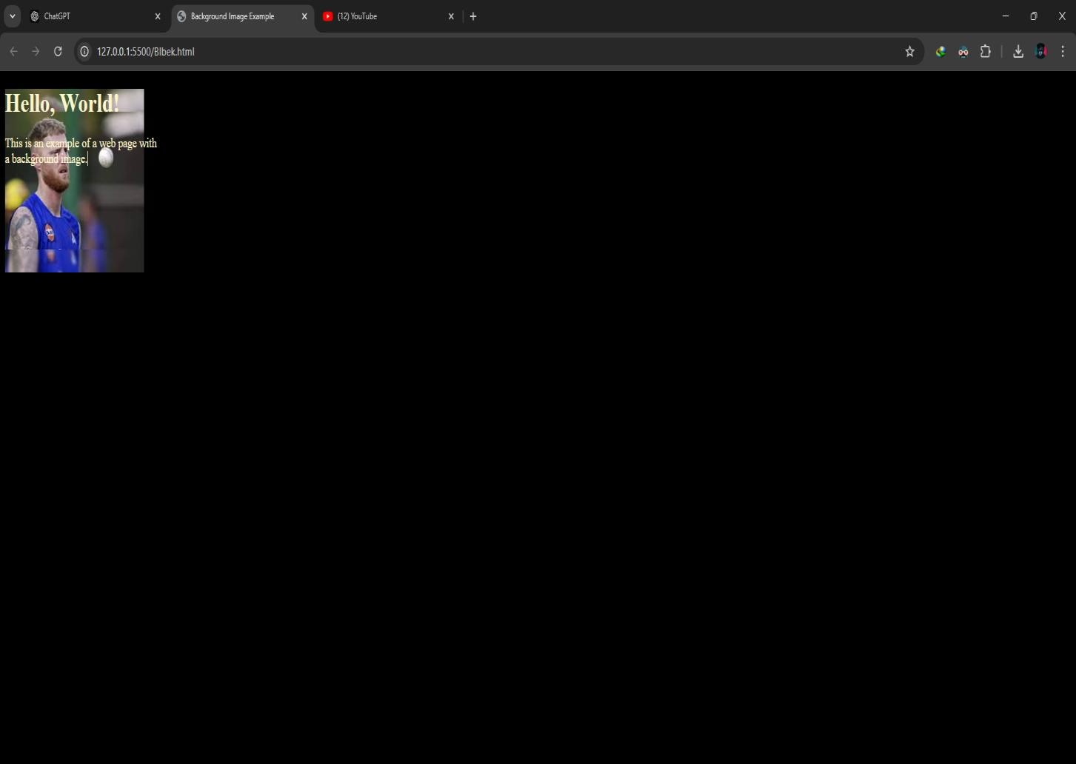

6. Create a web page to print a paragraph with 4-5 sentences, each sentence shall have a different font.

<!DOCTYPE html>

<html >

<head>

<title>Different Fonts Example</title>

</head>

<body>

<p style="font-family: Arial;">This is the first sentence in Arial font.</p>

<p style="font-family: Courier;">This is the second sentence in Courier font.</p>

<p style="font-family: Georgia;">This is the third sentence in

Georgia font.</p>

<p style="font-family: Times;">This is the fourth sentence in Times font.</p>

<p style="font-family: Verdana;">This is the fifth sentence in

Verdana font.</p>

</body>

</html>

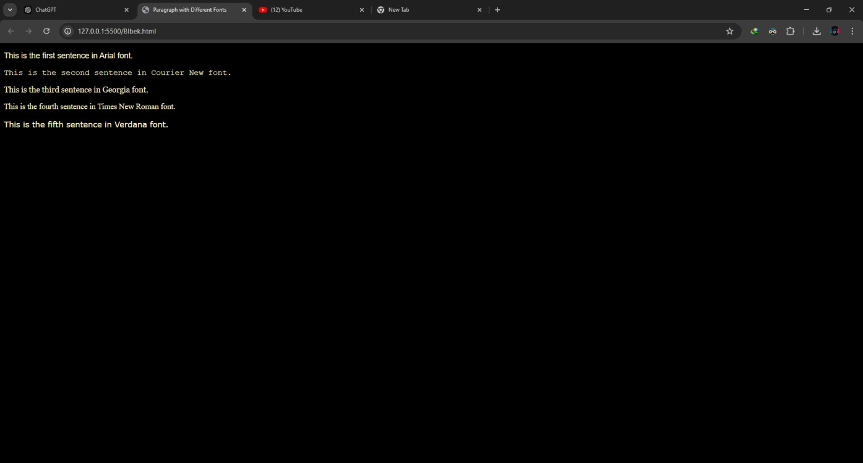

7. write HTML code to print a paragraph that is description of a book, it shall include the title of the book, its author name; name and title should be underlined and all adjectives shall be bold and Italics.

<!DOCTYPE html>

<html >

<head>

<title>Book Summary</title>

</head>

<body>

<p>

<u><strong><em>Rich Dad Poor Dad</em></strong></u> by

<u><strong><em>Robert Kiyosaki</em></strong></u> is a

<strong><em>brief</em></strong> but

<strong><em>powerful</em></strong> book that contrasts the <strong><em>wealthy</em></strong> mindset of one father with the <strong><em>struggles</em></strong> of another, emphasizing the importance of

<strong><em>financial education</em></strong>.

</p>

</body>

</html>

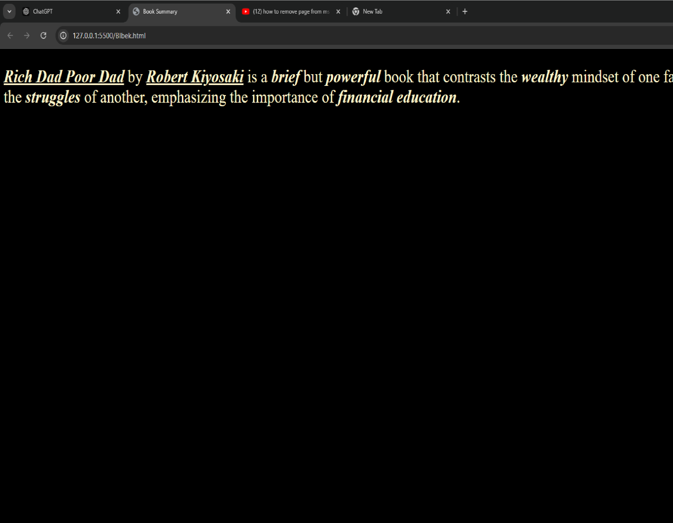

8. Write HTML code to print your name using Heading tag, every letter shall be of different heading size.

<!DOCTYPE html>

<html >

<head>

<title>Name </title>

</head>

<body>

<h1>R</h1>

<h2>i</h2>

<h3>v</h3>

<h4>a</h4>

</body>

</html>

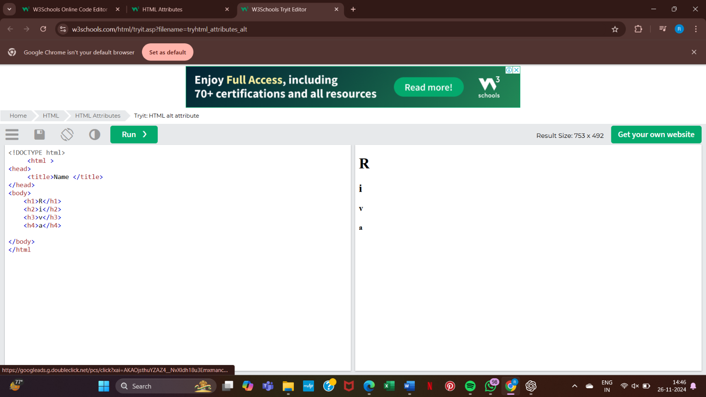

9. Write HTML code to print the sequence of numbers 1-20. Each number shall be in different line with number 2 next to it as subscript, an equal sign and the result.

<!DOCTYPE html>

<html >

<head>

<title>Number Sequence</title>

</head>

<body>

<h1> sequence Number 1-20</h1>

<p>1<sup>2</sup> = 1</p>

<p>2<sup>2</sup> = 4</p>

<p>3<sup>2</sup> = 9</p>

<p>4<sup>2</sup> = 16</p>

<p>5<sup>2</sup> = 25</p>

<p>6<sup>2</sup> = 36</p>

<p>7<sup>2</sup> = 49</p>

<p>8<sup>2</sup> = 64</p>

<p>9<sup>2</sup> = 81</p>

<p>10<sup>2</sup> = 100</p>

<p>11<sup>2</sup> = 121</p>

<p>12<sup>2</sup> = 144</p>

<p>13<sup>2</sup> = 169</p>

<p>14<sup>2</sup> = 196</p>

<p>15<sup>2</sup> = 225</p>

<p>16<sup>2</sup> = 256</p>

<p>17<sup>2</sup> = 289</p>

<p>18<sup>2</sup> = 324</p>

<p>19<sup>2</sup> = 361</p>

<p>20<sup>2</sup> = 400</p>

</body>

</html>

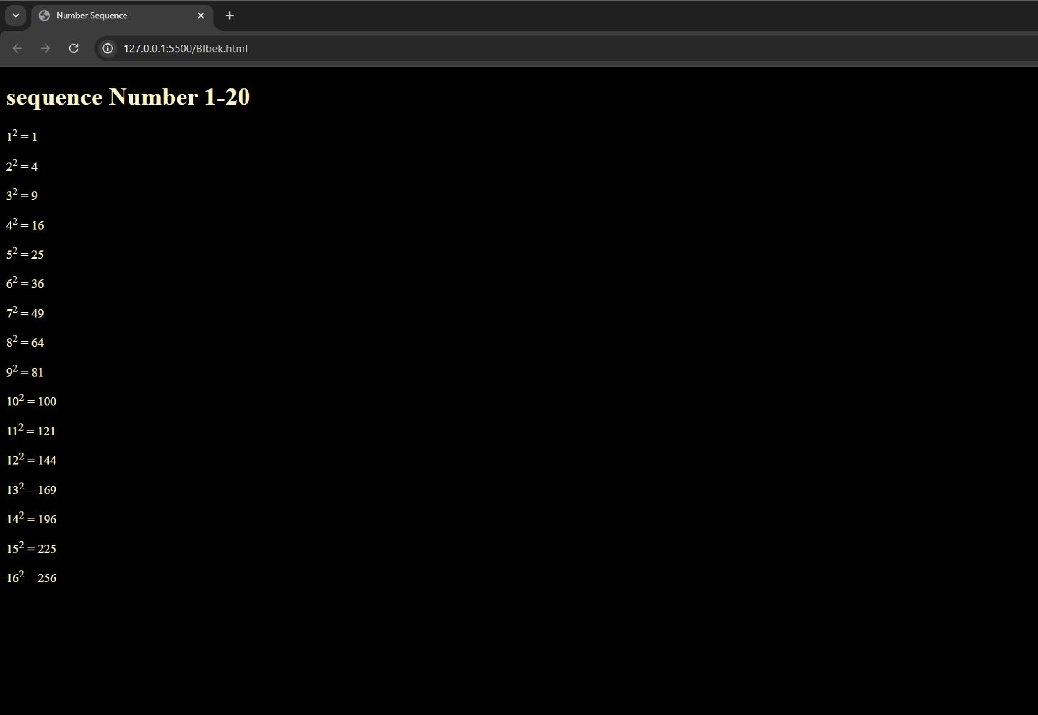

10. Write HTML code to display an image with border of size with width 200, height 200 pixels, leaving Hspace and Vspace of your choice with image hanging in the right side on the screen.

<!DOCTYPE html>

<html >

<head>

<meta charset="UTF-8">

<meta name="viewport" content="width=device-width, initial-scale=1.0">

<title>Image Display</title>

</head>

<body>

<img src="download.jpeg" alt="Description of Image" style="border: 2px solid black; width: 200px; height: 200px; margin-right: 20px; margin-top: 20px; float: right;">

</body>

</html>

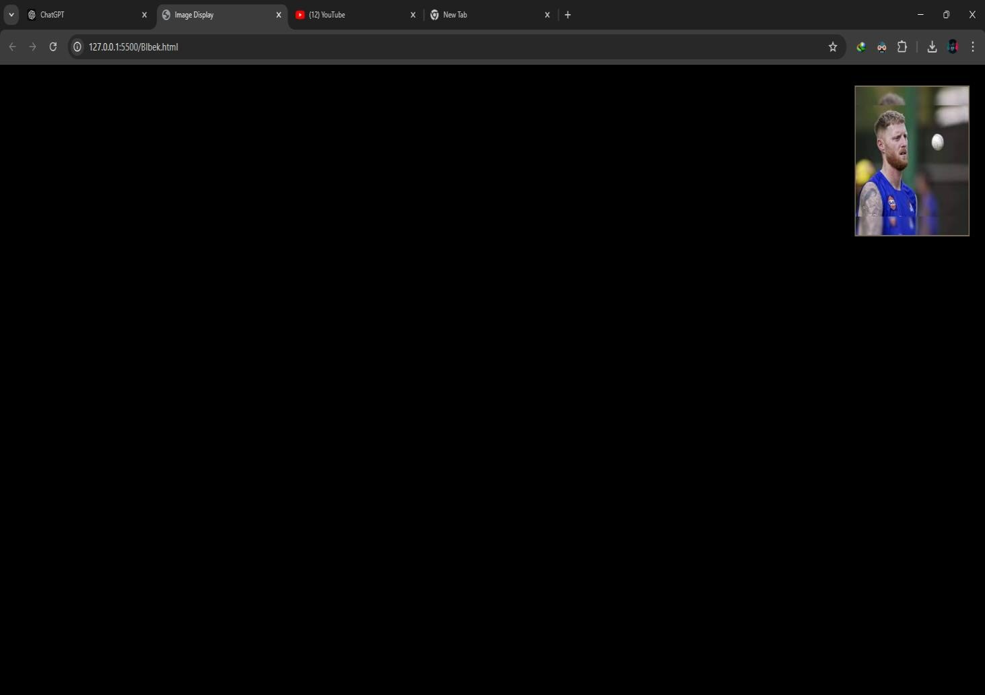

11.Write HTML code to create a web page with heading. The heading shall be displayed at the top-center of the page and the image shall be at the centre, just below the heading.

<html >

<head>

<title>Centered Heading and Image</title>

<style> h1 { text-align: center; font-size: 2em; margin-top: 20px;

}

.img-container { display: flex; justify-content: center; margin-top: 20px;

} img { max-width: 100%; height: auto;

}

</style>

</head>

<body>

<h1>BCA 1A</h1>

<div class="img-container">

<img src="your-image.jpg" alt="Centered Image"> </div>

</body>

</html>

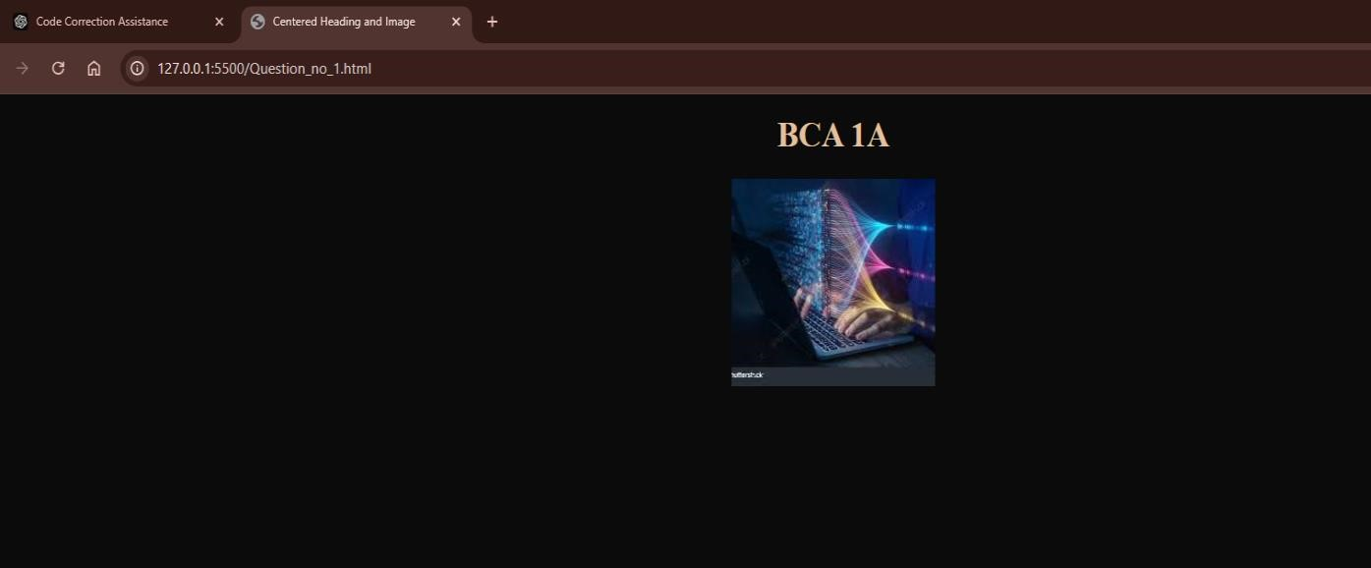

11. Write HTML code using Multimedia tags.

<html >

<head>

<title>Multimedia</title>

</head>

<body>

<h1>Multimedia Elements in HTML</h1>

<h2>Audio Example</h2>

<audio controls>

<source src="audio-file.mp3" type="audio/mpeg">

</audio>

<h2>Video Example</h2>

<video width="320" height="240" controls>

<source src="video-file.mp4" type="video/mp4">

<source src="video-file.ogv" type="video/ogg">

</video>

<h2>Embedded Object Example</h2>

<object data="document.pdf" type="application/pdf" width="400" height="500">

</object>

</body>

</html>

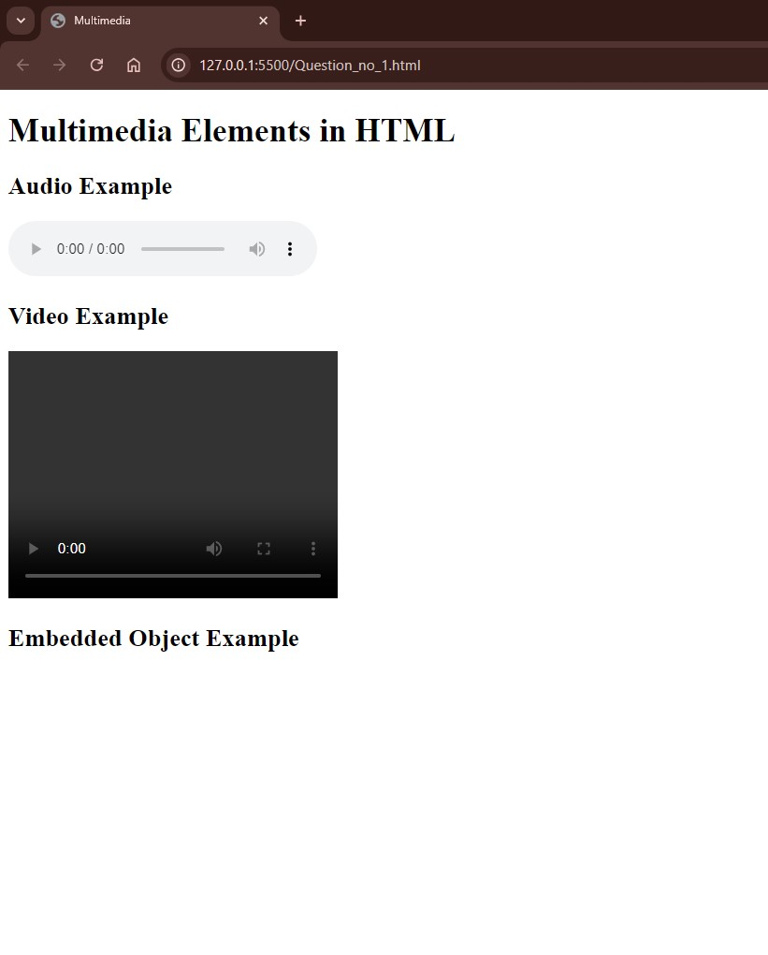

13.Create a Table using Rowspan and Colspan taking example of student Record.

<html>

<head>

<title>Student Record Table</title>

<style>

table { width: 80%; border-collapse: collapse; margin: 20px auto; font-family: Arial, sans-serif;

}

th, td {

border: 1px solid #000; padding: 8px; text-align: center;

} th {

background-color: #f2f2f2;

}

</style>

</head>

<body>

<h2 style="text-align: center;">Student Record</h2>

<table>

<tr>

<th rowspan="2">Student ID</th>

<th rowspan="2">Name</th>

<th colspan="3">Subjects</th>

<th rowspan="2">Grade</th>

</tr>

<tr>

<th>Math</th>

<th>Science</th>

<th>English</th>

</tr>

<tr>

<td>101</td>

<td>Alice</td>

<td>85</td>

<td>90</td>

<td>88</td>

<td>A</td>

</tr>

<tr>

<td>102</td>

<td>Bob</td>

<td>78</td>

<td>80</td>

<td>84</td>

<td>B</td>

</tr>

<tr>

<td>103</td>

<td>Charlie</td>

<td>92</td>

<td>88</td>

<td>91</td>

<td>A</td>

</tr>

</table>

</body>

</html>

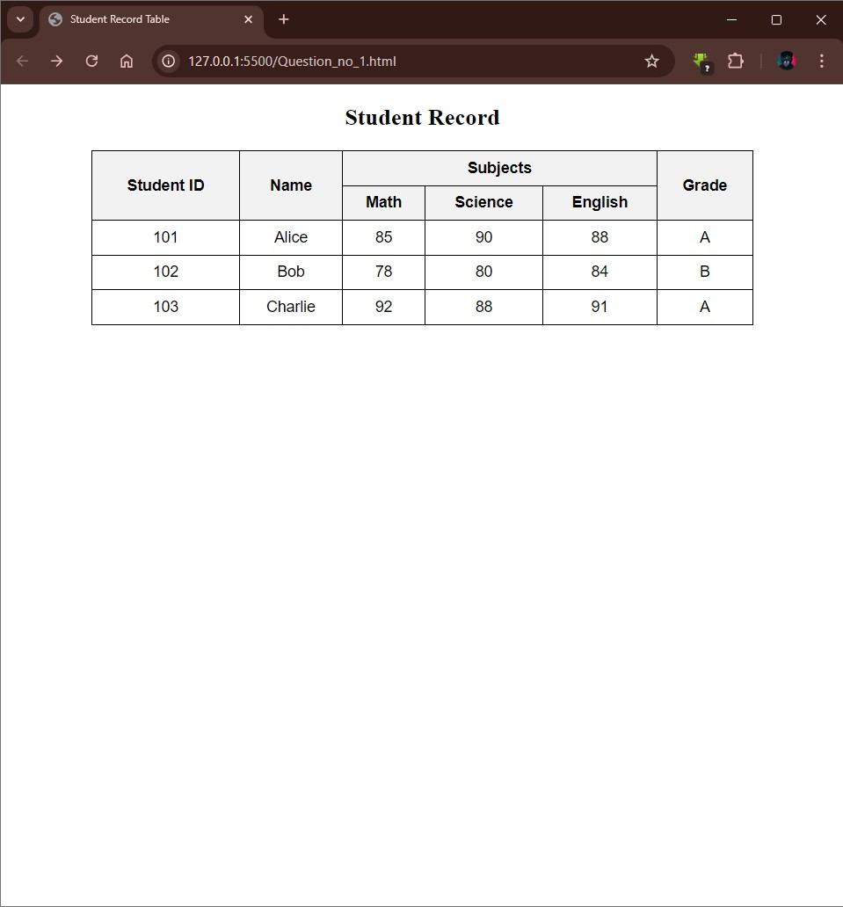

14.Write HTML code using table tag <table> and cellpadding and cell spacing as its attributes.

<html>

<head>

<title>Student Record Table</title>

</head>

<body>

<h2>Student Record</h2>

<table border="1" cellpadding="10" cellspacing="5">

<tr>

<th>Roll No</th>

<th>Name</th>

<th>Class</th>

<th>Marks</th>

</tr>

<tr>

<td>1</td>

<td>John Doe</td>

<td>10</td> <td>85</td>

</tr>

<tr>

<td>2</td>

<td>Jane Smith</td>

<td>10</td>

<td>90</td>

</tr>

<tr>

<td>3</td>

<td>Alex Johnson</td>

<td>9</td>

<td>88</td>

</tr>

</table>

</body>

</html>

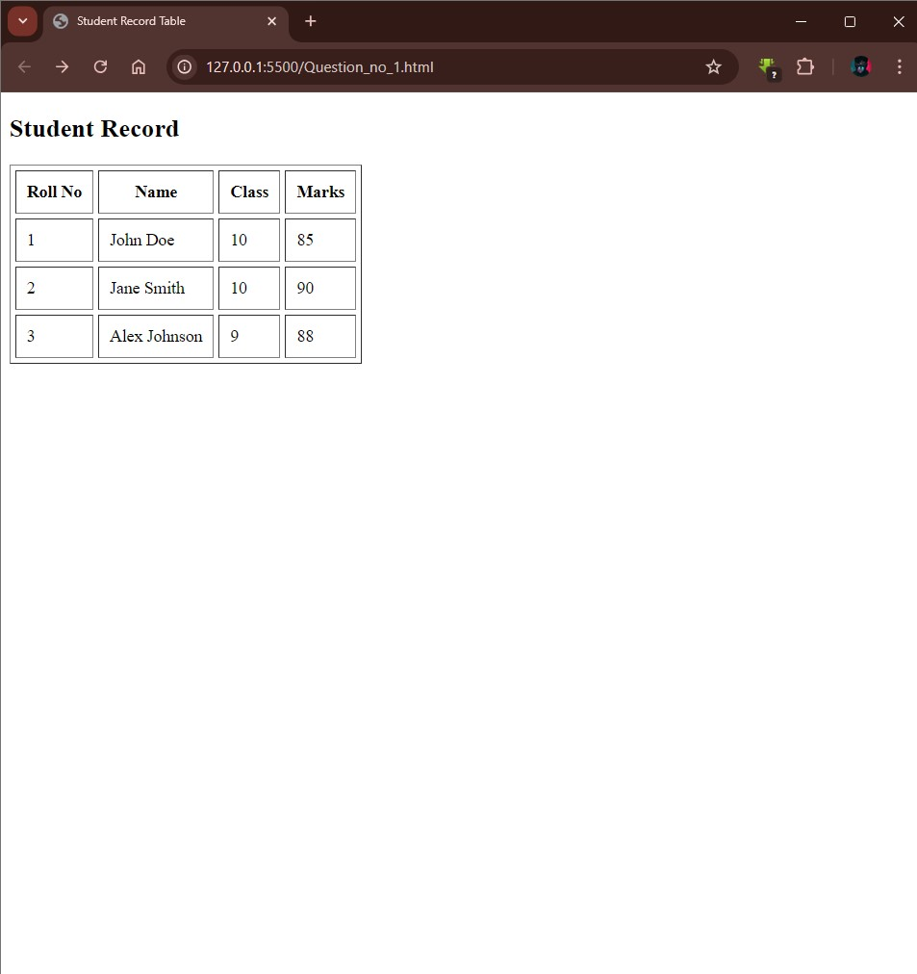

15.Create unordered, ordered and definition Lists taking example of your subjects in MCA IST, IInd and IIIrd Semester.

<html >

<head>

<title>MCA Subjects Lists</title>

</head>

<body>

<h2>Subjects in MCA by Semester (Unordered List)</h2>

<ul>

<li>First Semester

<ul>

<li>Programming in C</li>

<li>Mathematics for Computing</li>

<li>Database Management Systems</li>

<li>Computer Organization and Architecture</li>

</ul>

</li>

<li>Second Semester

<ul>

<li>Data Structures</li>

<li>Object-Oriented Programming in Java</li>

<li>Operating Systems</li>

<li>Software Engineering</li>

</ul>

</li>

<li>Third Semester

<ul>

<li>Web Technologies</li>

<li>Computer Networks</li>

<li>Artificial Intelligence</li>

<li>Data Mining and Warehousing</li>

</ul>

</li>

</ul>

<h2>Subjects in MCA by Semester (Ordered List)</h2>

<ol>

<li>First Semester

<ol>

<li>Programming in C</li>

<li>Mathematics for Computing</li>

<li>Database Management Systems</li>

<li>Computer Organization and Architecture</li>

</ol>

</li>

<li>Second Semester

<ol>

<li>Data Structures</li>

<li>Object-Oriented Programming in Java</li>

<li>Operating Systems</li>

<li>Software Engineering</li>

</ol>

</li>

<li>Third Semester

<ol>

<li>Web Technologies</li>

<li>Computer Networks</li>

<li>Artificial Intelligence</li>

<li>Data Mining and Warehousing</li>

</ol>

</li>

</ol>

<h2>Explanation of Selected MCA Subjects (Definition List)</h2> <dl>

<dt>Programming in C</dt>

<dd>A foundational course in programming that covers syntax, data types, control structures, and basic algorithms.</dd>

<dt>Database Management Systems</dt>

<dd>Introduces concepts of databases, relational models, SQL, and database design principles.</dd>

<dt>Operating Systems</dt>

<dd>Covers OS fundamentals, including process management, memory management, file systems, and security.</dd>

<dt>Data Mining and Warehousing</dt>

<dd>Focuses on extracting useful information from large data sets and designing data warehouses.</dd>

</dl>

</body>

</html>

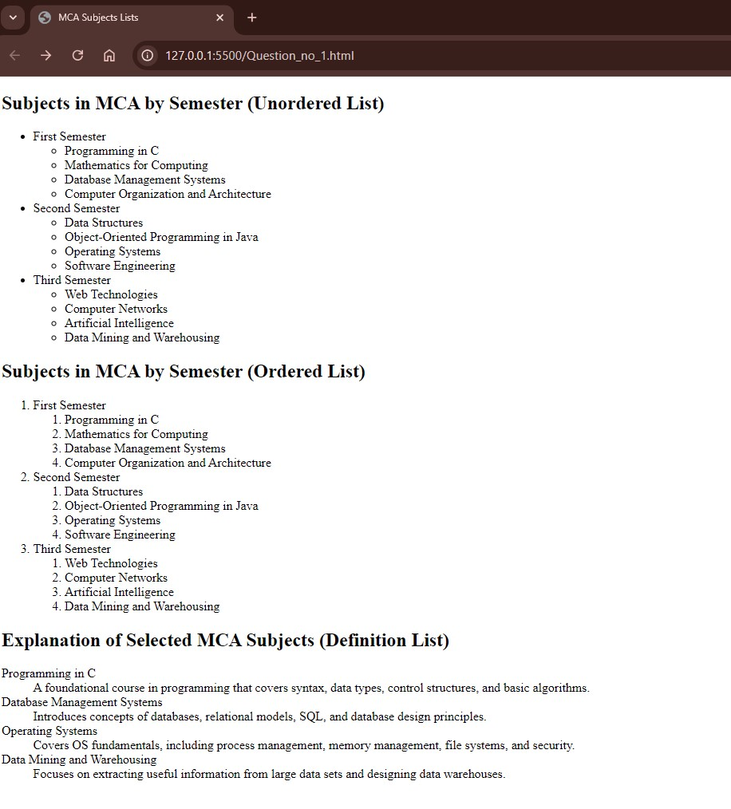

16.Write HTML code using <frameset> and <frame> tag with all its attributes <html>

<head>

<title>Example of Frameset and Frame</title>

</head>

<frameset cols="30%,70%" rows="50%,50%">

<frame src="frame1.html" name="frame1" scrolling="auto" noresize="noresize" marginwidth="10" marginheight="10">

<frame src="frame2.html" name="frame2" scrolling="yes" noresize="noresize" marginwidth="15" marginheight="15">

<frame src="frame3.html" name="frame3" scrolling="no" marginwidth="20" marginheight="20">

<frame src="frame4.html" name="frame4" scrolling="yes" noresize="noresize" marginwidth="25" marginheight="25">

</frameset>

<noframes>

<body>

<p>This page uses frames, but your browser does not support them.</p> </body>

</noframes>

</html>

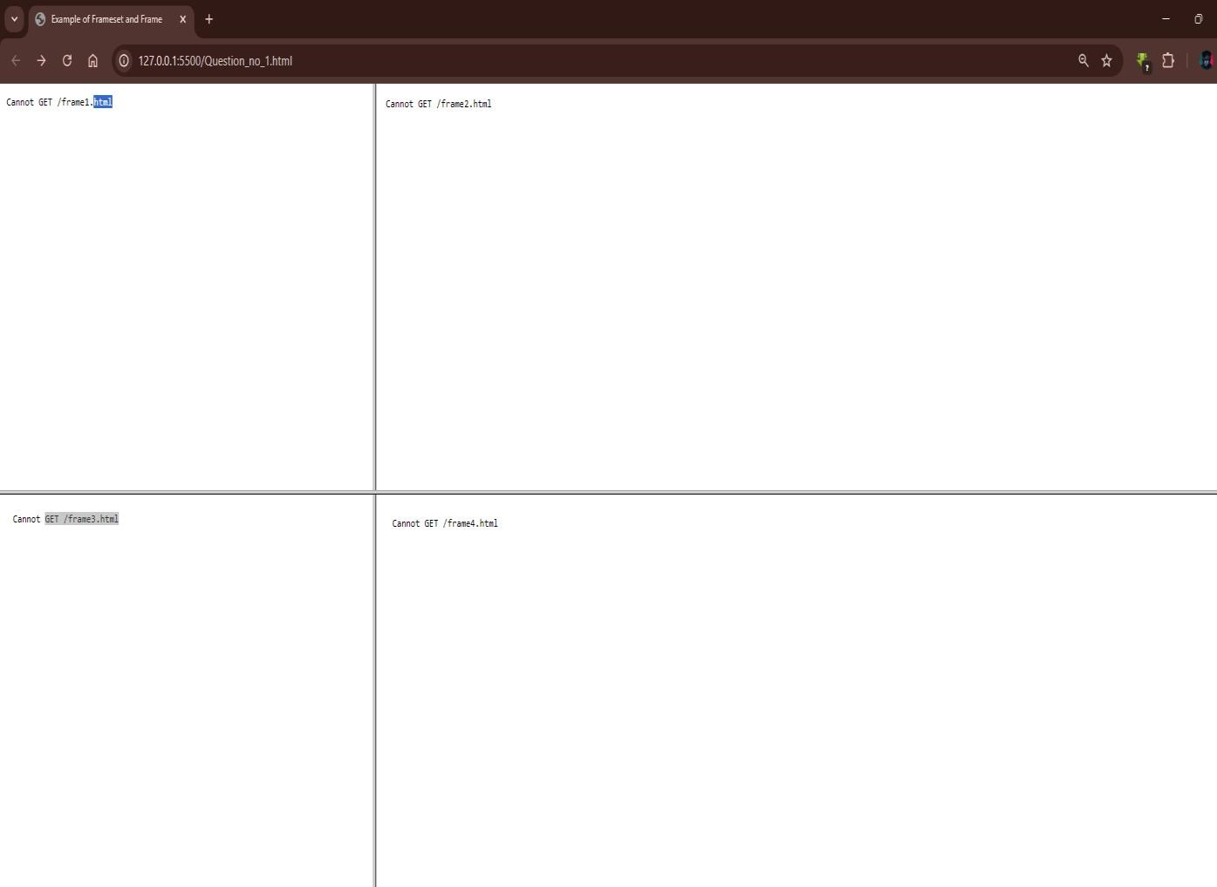

17.Write HTML code to design a form in HTML using controls and buttons such as Textbox, Text area, password, submit button, browse button, drop-down menu.

<html>

<head>

<title>Sample Form</title>

</head>

<body>

<h2>Sample Form</h2>

<form action="/submit" method="post">

<label for="name">Name:</label>

<input type="text" id="name" name="name" required><br><br>

<label for="password">Password:</label>

<input type="password" id="password" name="password" required><br><br>

<label for="comments">Comments:</label><br>

<textarea id="comments" name="comments" rows="4" cols="50"></textarea><br><br>

<label for="fileUpload">Upload File:</label>

<input type="file" id="fileUpload" name="fileUpload"><br><br>

<!-- Drop-Down Menu -->

<label for="country">Country:</label>

<select id="country" name="country">

<option value="nepal">Nepal</option>

<option value="india">India</option>

<option value="usa">USA</option>

<option value="uk">UK</option>

</select><br><br>

<button type="submit">Submit</button>

</form>

</body>

</html>

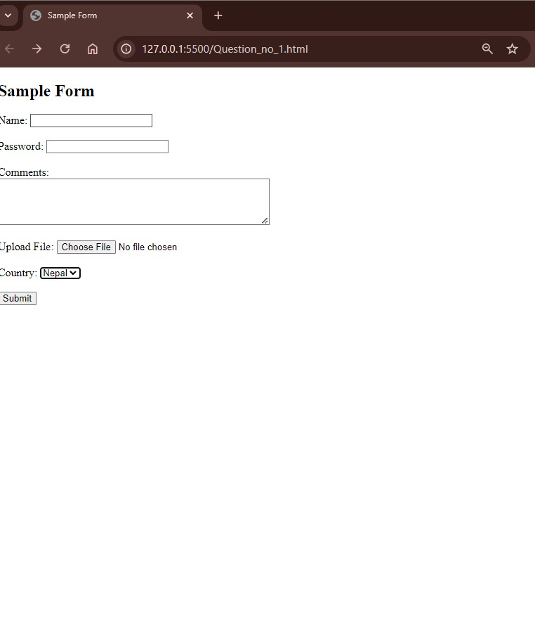

18.Write HTML code to design a Registration Form in HTML.

<html >

<head>

<title>Registration Form</title>

<style> body {

font-family: Arial, sans-serif; background-color: #f0f0f0; display: flex; justify-content: center; align-items: center; height: 100vh; margin: 0;

}

.form-container { width: 300px; padding: 20px; background-color: #fff; border-radius: 8px;

box-shadow: 0 4px 8px rgba(0, 0, 0, 0.2);

} h2 {

text-align: center;

color: #333;

} label { display: block; margin: 10px 0 5px;

}

input[type="text"], input[type="email"], input[type="password"], input[type="tel"], select { width: 100%; padding: 8px; margin-bottom: 10px; border: 1px solid #ccc; border-radius: 4px;

}

.gender { margin: 5px 0;

}

input[type="submit"] { width: 100%; padding: 10px; background-color: #4CAF50; color: white; border: none; border-radius: 4px;

cursor: pointer;

}

input[type="submit"]:hover { background-color: #45a049;

}

</style>

</head>

<body>

<div class="form-container">

<h2>Registration Form</h2>

<form action="submit_form.php" method="post">

<label for="name">Full Name</label>

<input type="text" id="name" name="name" required>

<label for="email">Email</label>

<input type="email" id="email" name="email" required>

<label for="password">Password</label>

<input type="password" id="password" name="password" required>

<label for="gender">Gender</label>

<select id="gender" name="gender">

<option value="male">Male</option>

<option value="female">Female</option>

<option value="other">Other</option>

</select>

<label for="phone">Phone Number</label>

<input type="tel" id="phone" name="phone" placeholder="Enter a">

<input type="submit" value="Register">

</form>

</div>

</body>

</html>

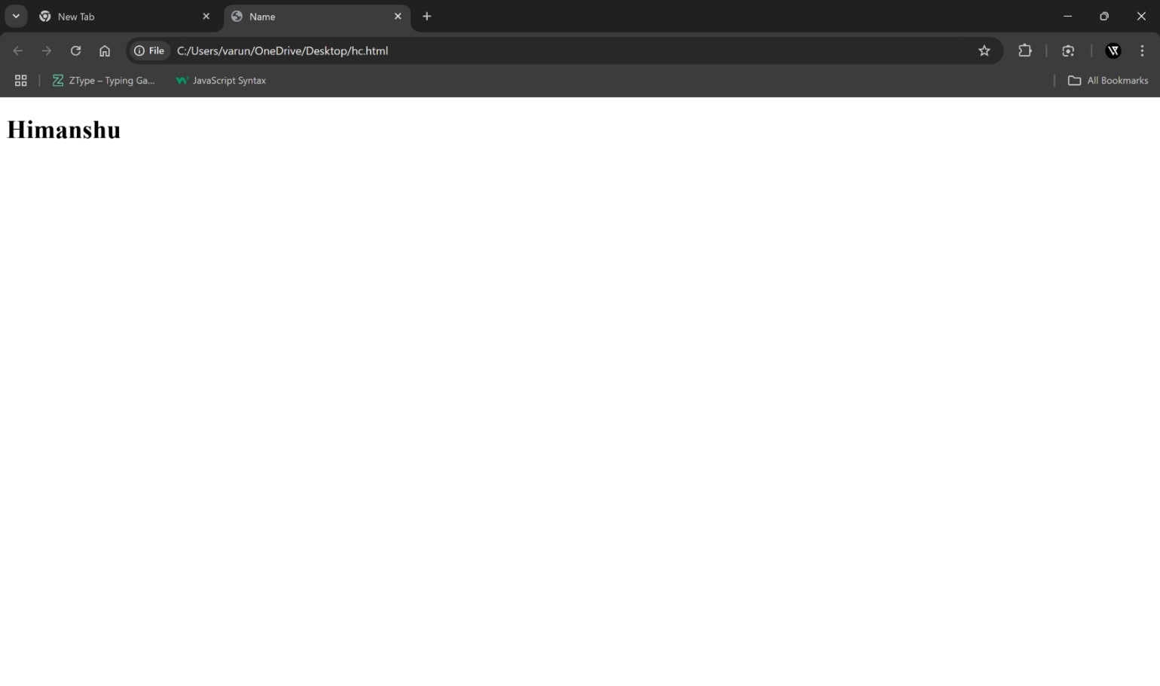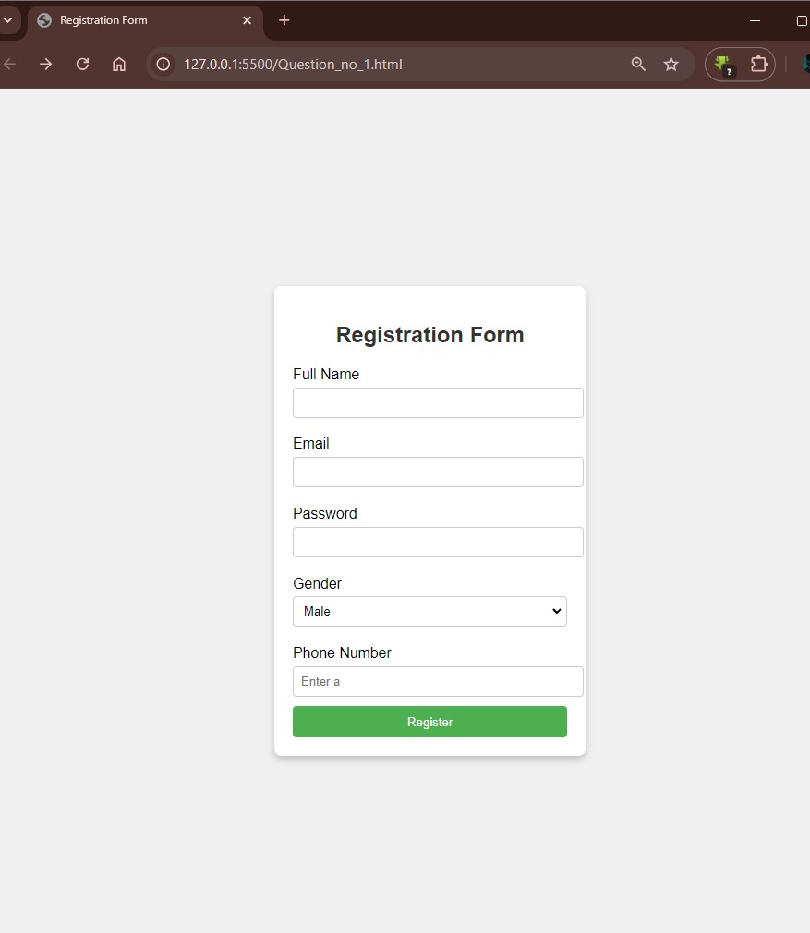

19. Write HTML code to design a student admission Form in HTML.

<html >

<head>

<title>Student Admission Form</title>

<style> body {

font-family: Arial, sans-serif; margin: 0; padding: 0;

background-color: #f4f4f4;

}

.container { width: 60%; margin: 0 auto; background-color: #fff; padding: 20px;

box-shadow: 0 0 10px rgba(0, 0, 0, 0.1); margin-top: 50px;

} h2 {

text-align: center; color: #333;

}

label { display: block; margin: 10px 0 5px;

}

input, select, textarea { width: 100%; padding: 8px; margin: 5px 0 15px; border: 1px solid #ccc; border-radius: 5px;

}

button { width: 100%; padding: 10px; background-color: #4CAF50;

color: #fff; border: none; border-radius: 5px; font-size: 16px;

}

button:hover { background-color: #45a049;

}

</style>

</head>

<body>

<div class="container">

<h2>Student Admission Form</h2>

<form action="#" method="post">

<label for="fullName">Full Name:</label>

<input type="text" id="fullName" name="fullName" required>

<label for="dob">Date of Birth:</label>

<input type="date" id="dob" name="dob" required>

<label for="gender">Gender:</label>

<select id="gender" name="gender" required>

<option value="male">Male</option>

<option value="female">Female</option>

<option value="other">Other</option>

</select>

<label for="course">Course:</label>

<select id="course" name="course" required>

<option value="science">Science</option>

<option value="commerce">Commerce</option>

<option value="arts">Arts</option>

</select>

<label for="phone">Contact Number:</label>

<input type="tel" id="phone" name="phone" required>

<label for="email">Email Address:</label>

<input type="email" id="email" name="email" required>

<label for="address">Address:</label>

<textarea id="address" name="address" rows="4" required></textarea>

<button type="submit">Submit</button>

</form>

</div>

</body>

</html>

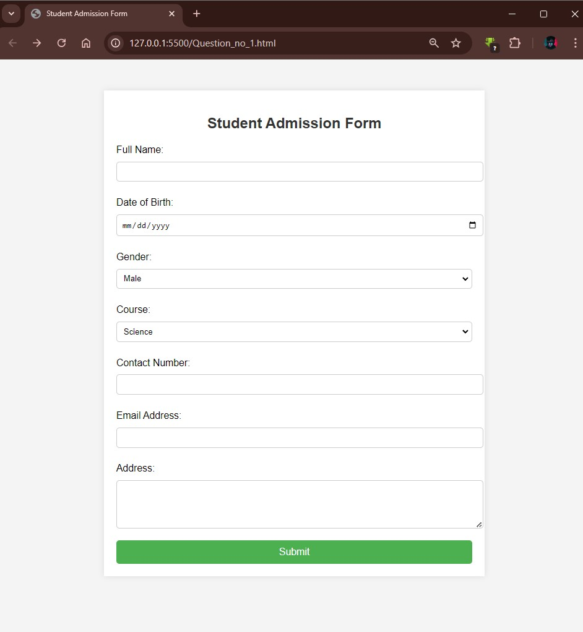

20.Create a proper home page of your own using any components and styles.

<html >

<head>

<title>My Homepage</title>

<style> body {

font-family: Arial, sans-serif; margin: 0; padding: 0;

background-color: #f4f4f4;

}

header {

background-color: #333; color: white; padding: 10px 0; display: flex;

justify-content: space-between; align-items: center; padding: 0 20px;

}

header .logo h1 { margin: 0;

}

header nav ul { list-style: none; margin: 0; padding: 0; display: flex;

}

header nav ul li { margin: 0 15px;

}

header nav ul li a { color: white; text-decoration: none; font-size: 16px;

}

main { padding: 20px;

}

main section { margin-bottom: 30px;

}

main section h2 { color: #333;

}

/* Footer Section */ footer { background-color: #333; color: white; text-align: center; padding: 10px 0; position: relative; bottom: 0; width: 100%;

}

</style>

</head>

<body>

<header>

<div class="logo">

<h1>My Homepage</h1>

</div>

<nav>

<ul>

<li><a href="#home">Home</a></li>

<li><a href="#about">About</a></li>

<li><a href="#services">Services</a></li>

<li><a href="#contact">Contact</a></li>

</ul>

</nav>

</header>

<!-- Main Content Section -->

<main>

<section id="home">

<h2>Welcome to My Homepage</h2>

<p>This is a simple homepage to showcase HTML and CSS structure.</p>

</section>

<section id="about">

<h2>About Me</h2>

<p>Learn more about me and my background.</p>

</section>

<section id="services">

<h2>Services</h2>

<p>We offer a variety of services to meet your needs.</p> </section>

<section id="contact">

<h2>Contact</h2>

<p>Get in touch with me through the contact information provided here.</p>

</section>

</main>

<footer>

<p>&copy; 2024 My Homepage. All rights reserved.</p>

</footer>

</body>

</html>

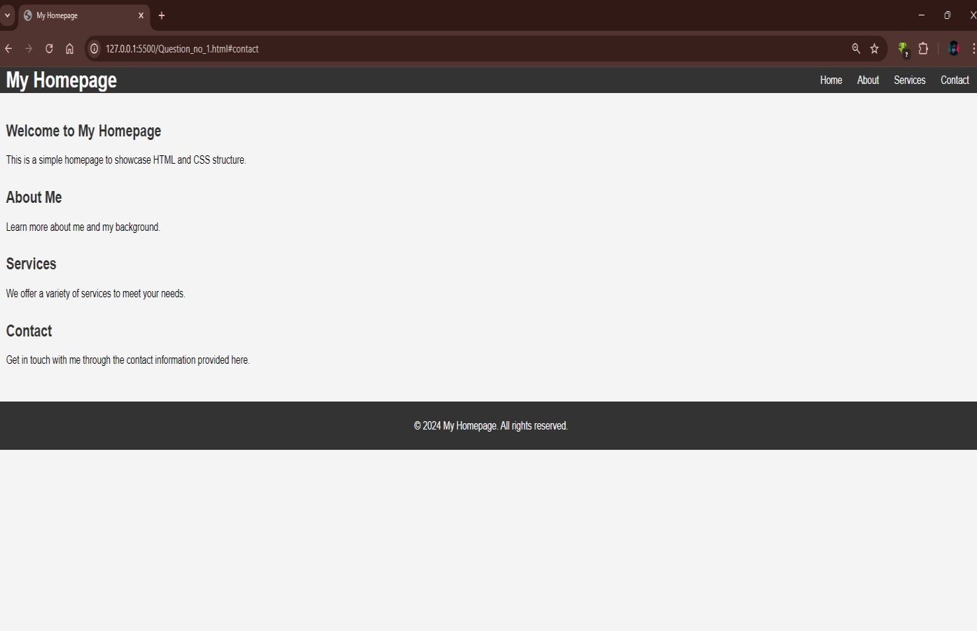

21.Write HTML code for including Local hyperlinking in a web page.

<html >

<head>

<title>Local Hyperlinking Example</title>

</head>

<body>

<h1>Local Hyperlinking in HTML</h1>

<p>

<a href="about.html">Go to About Page</a>

</p>

<p>

<a href="#section1">Go to Section 1</a>

</p>

<hr>

<h2 id="section1">Section 1</h2>

<p>This is the content of Section 1. You can navigate here by clicking the link above.</p>

<h2 id="section2">Section 2</h2>

<p>This is the content of Section 2.</p>

<h2 id="section3">Section 3</h2>

<p>This is the content of Section 3.</p>

</body>

</html>

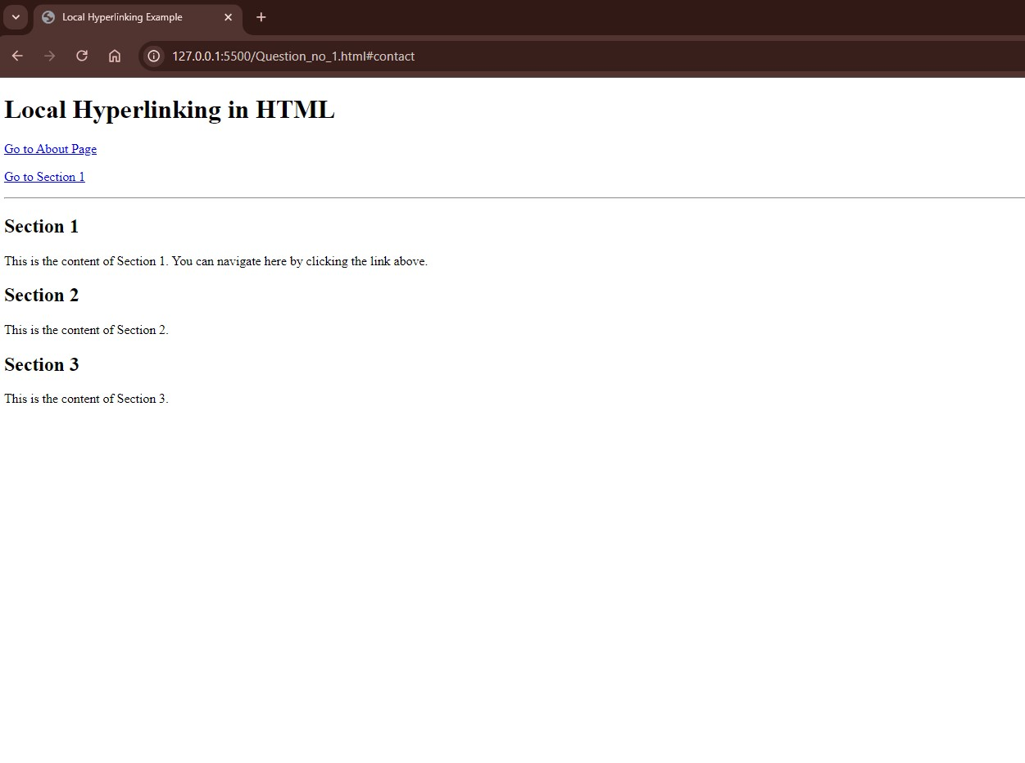

22.Write HTML code for including Inter hyperlinking in a web page.

<html lang="en">

<head>

<title>Inter Hyperlinking Example</title>

</head>

<body>

<h1>Welcome to My Website</h1>

<p>Click on the following links to navigate:</p>

<ul>

<li><a href="about.html">About Us</a></li>

<li><a href="services.html">Services</a></li>

<li><a href="contact.html">Contact Us</a></li> </ul>

</body>

</html>

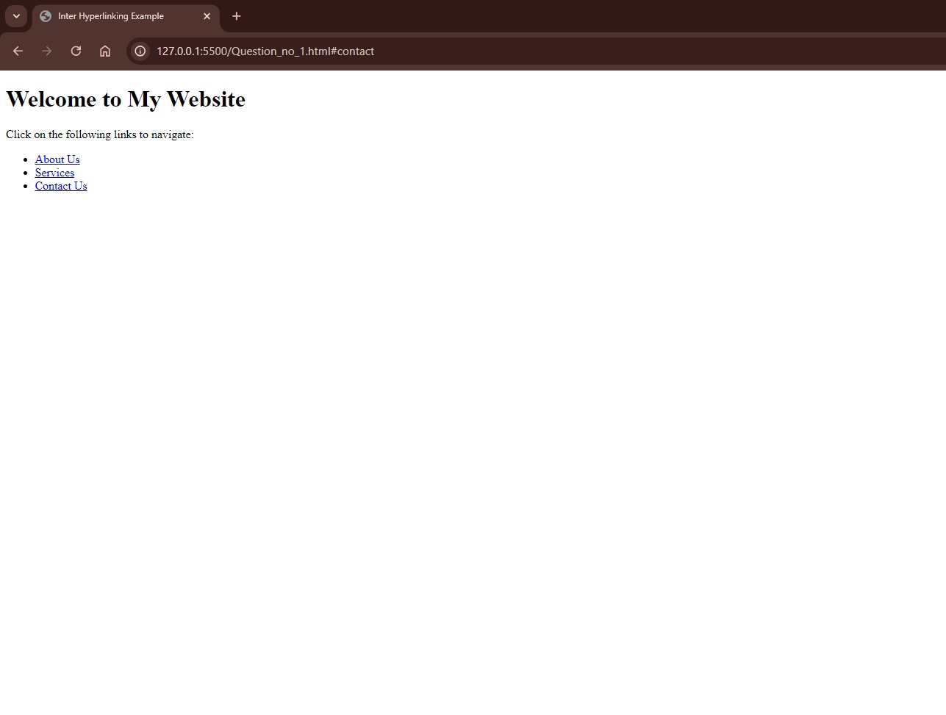

23. Write HTML code for including External hyperlinking in a web page.

<!DOCTYPE html>

<html lang="en">

<head>

<title>External Hyperlink Example</title>

</head>

<body>

<h1>External Hyperlink Example</h1>

<p>Click the link below to visit an external website:</p>

<a href="https://www.example.com" target="_blank">Visit Example Website</a>

</body>

</html>

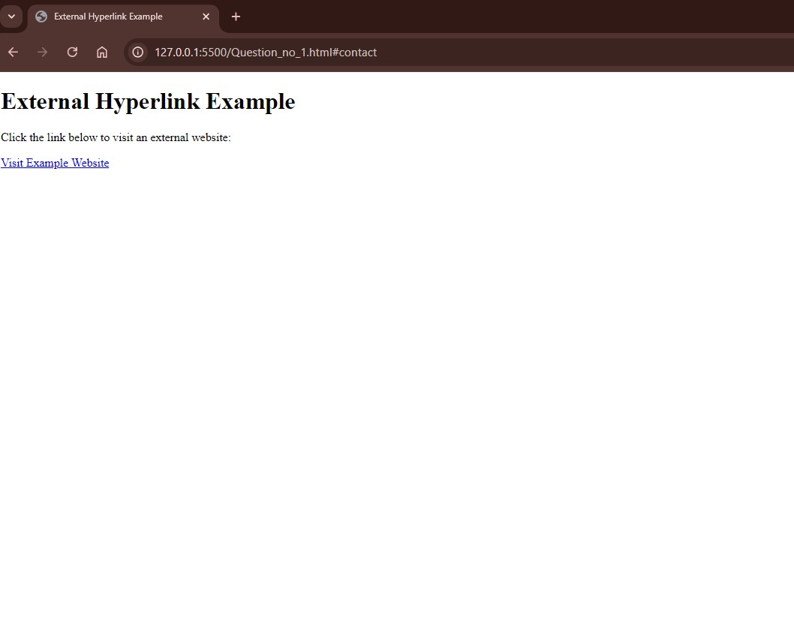

24.Write code to show External CSS with HTML code.

<!--this is html file-->

<html >

<head>

<title>External CSS Example</title>

<link rel="stylesheet" href="style.css">

</head>

<body>

<h1>Welcome to My Website</h1>

<p>This is an example of using external CSS with HTML.</p>

</body>

</html>

<!--this is css file--> /* style.css */ body {

background-color: lightblue; font-family: Arial, sans-serif;

}

h1 {

color: darkblue; text-align: center;

}

p {

font-size: 16px; color: darkgreen;

}

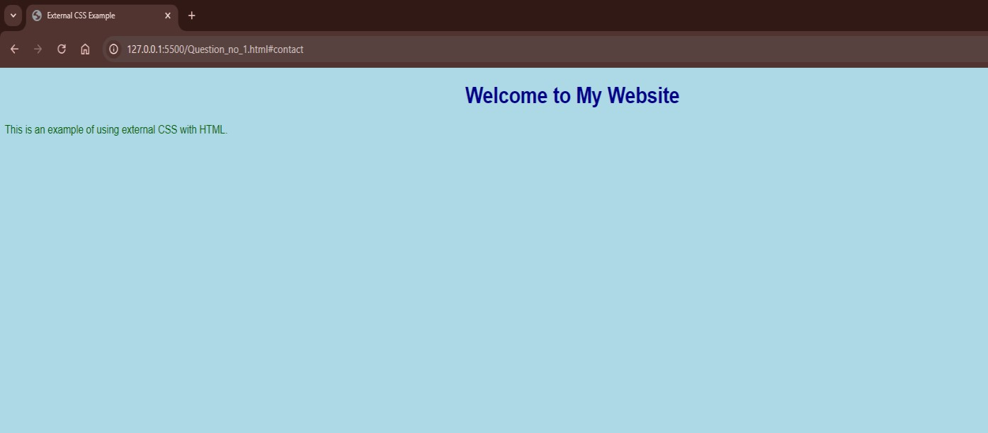

25.Write code to show Internal CSS with HTML code.

<html >

<head>

<title>Internal CSS Example</title>

<style>

/* Internal CSS */ body {

font-family: Arial, sans-serif; background-color: #f4f4f4; margin: 0; padding: 0;

} h1 { color: #333; text-align: center;

} p { color: #666; font-size: 18px; padding: 10px;

}

.highlight { color: red; font-weight: bold; }

</style>

</head>

<body>

<h1>Welcome to Internal CSS Example</h1>

<p>This is an example of using internal CSS within an HTML document.</p>

<p class="highlight">This paragraph uses a custom class with red color and bold text.</p>

</body>

</html>

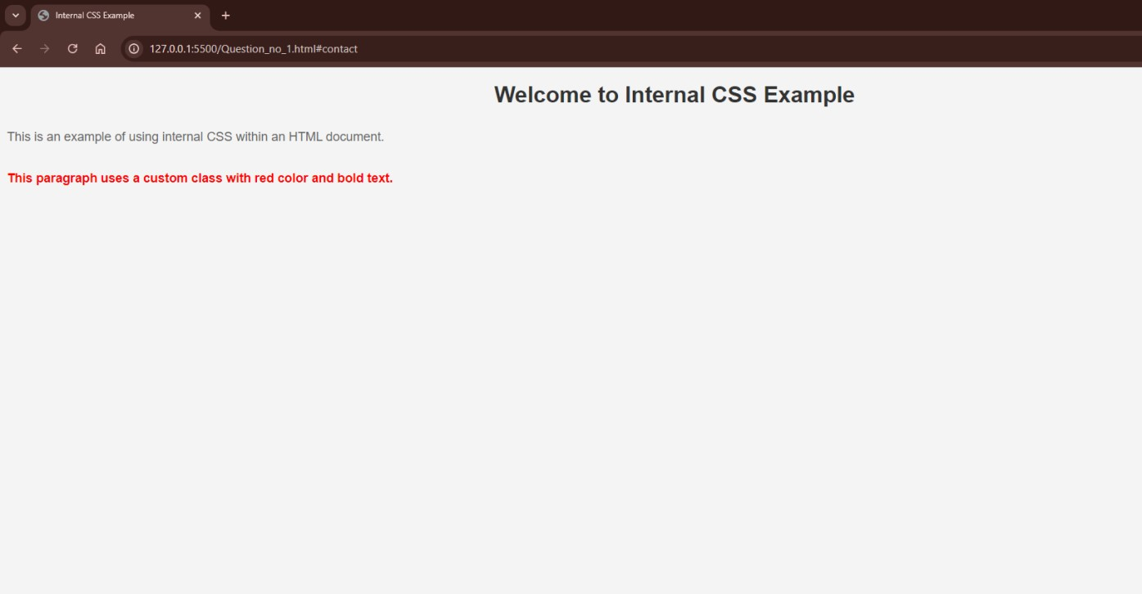

26.Write code to show Inline CSS with HTML code.

<!DOCTYPE html>

<html lang="en">

<head>

<title>Inline CSS Example</title>

</head>

<body>

<h1 style="color: blue; text-align: center;">Welcome to Inline CSS Example</h1>

<p style="font-size: 18px; color: green;">This is an example of using inline CSS in HTML.</p>

<button style="background-color: orange; color: white; padding: 10px 20px;">Click Me</button>

</body>

</html>

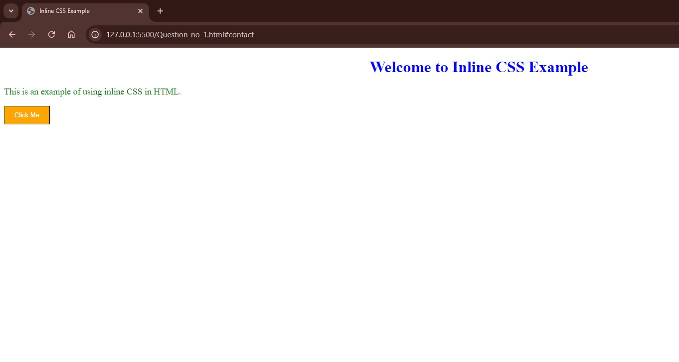

27.Write a program to add two numbers using form in JavaScript.

<html >

<head>

<title>Add Two Numbers</title>

</head>

<body>

<h2>Add Two Numbers</h2>

<form id="addForm">

<label for="num1">Enter First Number:</label>

<input type="number" id="num1" required><br><br>

<label for="num2">Enter Second Number:</label>

<input type="number" id="num2" required><br><br>

<button type="button" onclick="addNumbers()">Add</button> </form>

<h3>Result: <span id="result"></span></h3>

<script>

function addNumbers() {

let num1 =

parseFloat(document.getElementById('num1').value); let num2 =

parseFloat(document.getElementById('num2').value);

// Add the numbers let sum = num1 + num2;

document.getElementById('result').textContent = sum;

}

</script>

</body>

</html>

